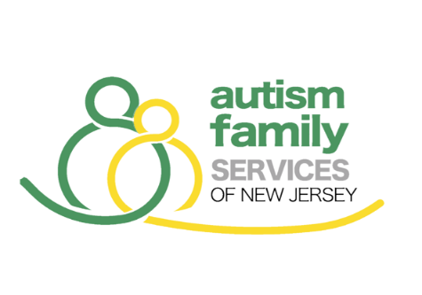

2026 SCHOLARSHIP APPLICATION

Applicant Information
Applicant’s  Full Name: |  |  |  |  |  |  |  |  | DOB:
(Last) |  | (First) |  |  |  |  | (M.I.)
Address:
(Street Address) |  |  |  |  |  |  | (Apartment/Unit #)
(City) |  |  |  |  |  |  | (State) |  |  |  | (ZIP Code)
Phone: | ( ) |  |  | E-mail Address:
Parent’s Name: OR |  |  |  | Phone: | ( )
Guardian’s Name: |  |  |  | Phone: | ( )

High School Information
High School: |  |  |  | High School Phone Number:
Address:
Guidance Counselor:
Graduation Date: |  |  |  | College Entrance Date:

Academic Record
Current GPA:
SAT Score | Total: |  | Verbal: |  |  |  |  | Math:
ACT Score | Total:
Class Rank | ________ out of ________

Previous Experience

- Describe your participation in extracurricular activities, in employment, community activities, sports, religion or others.

- List any academic awards or honors that you received during high school.

Personal Statement (on a separate piece of paper)

Please pick one of the two essay questions listed below:
- Discuss a situation where you have advocated for yourself or others. How did your advocacy efforts make a difference in your/someone’s life?
- Share a significant obstacle that you have been faced with and how you overcame adversity

Enclosures
- Copy of school transcript
- Letter verifying admission to further education
- Statement of diagnosis from a physician, indicating Asperger’s, Autism, PDD-NOS (and other disabilities, if applicable)
- Two letters of recommendations from any of the following: teacher, coach, guidance counselor, principal, employer, clergy
I give my permission for the commercial use of photographs and text submitted to Autism Family Services of New Jersey. This permission specifically includes such use as advertising, general publication and distribution. (if under the age of 18 please have parent/guardian sign also)
Signature: |  |  |  |  |  |  |  | Date:
Guardian Signature: |  |  |  |  |  |  |  | Date:

All documents must be received by Autism Family Services of New Jersey by
Friday, April 24, 2026
in order for your application to be reviewed.
Please use separate sheets to complete the written part of this application.
When you have completed the application, send the application and the supporting documents to:

scholarships@autismfamilyservicesnj.org

