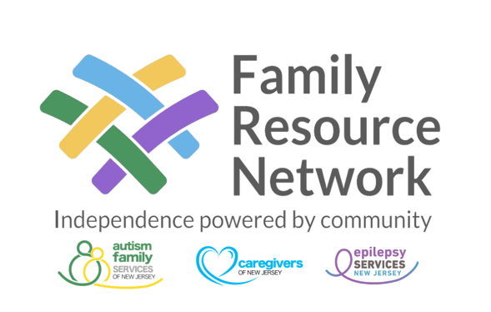

2024 SCHOLARSHIP for Blind and Visually Impaired APPLICATION
APPLICANT INFORMATION

Applicant’s full name (First, Middle, and Last):

Date of Birth:

Home Address
Street Address:

Apartment or unit number:

City:

State:

Zip code:

Phone Number:

Email Address:

Parent or Guardian’s name:

Parent or Guardian’s phone number:

HIGH SCHOOL INFORMATION
High School:

High School Address:

Guidance Counselor:

Graduation Date:

ACADEMIC RECORD
Current GPA:

SAT Score:

ACT Score:

Class Rank:

PREVIOUS EXPERIENCE
Please use a separate sheet if needed.

1. Describe your participation in extracurricular activities, including involvement in employment, community activities, sports, religion or other areas.

2. List any academic awards or honors that you received during high school.

PERSONAL STATEMENT

Please use a separate sheet to complete your personal statement.

Write a brief personal statement explaining your academic and career goals, and how the EDGE scholarship will assist you with reaching these goals. If there have been any circumstances that have adversely affected your academic or extracurricular performance(s), you may include an explanatory paragraph that will be considered in the selection process.

ENCLOSURES
Please include the following documents with your completed application:
- Copy of school transcript.
- Letter verifying admission to college or university. (If unavailable, please include addresses and telephone numbers to admissions offices where you have applied)
- Statement of diagnosis from physician indicating the type and severity of your visual impairment (and other disabilities if applicable).
- Two letters of recommendation from any of the following: teachers, guidance counselors, coaches, principles, employers, clergy.

PERMISSION AND SIGNATURES
I give my permission for the commercial use of photographs and text submitted to the family resource network. This permission specifically includes such use as advertising, general publication, and distribution. If under the age of eighteen, please have parent/guardian sign also.

Signature: Date:

Parent/guardian Signature: Date:

All documents must be received by The Family Resource Network by
Friday, April 26, 2024
in order for your application to be reviewed.
Please use separate sheets to complete the written part of this application.
When you have completed the application, send the application and the supporting documents to:
scholarships@familyresourcenetwork.org

